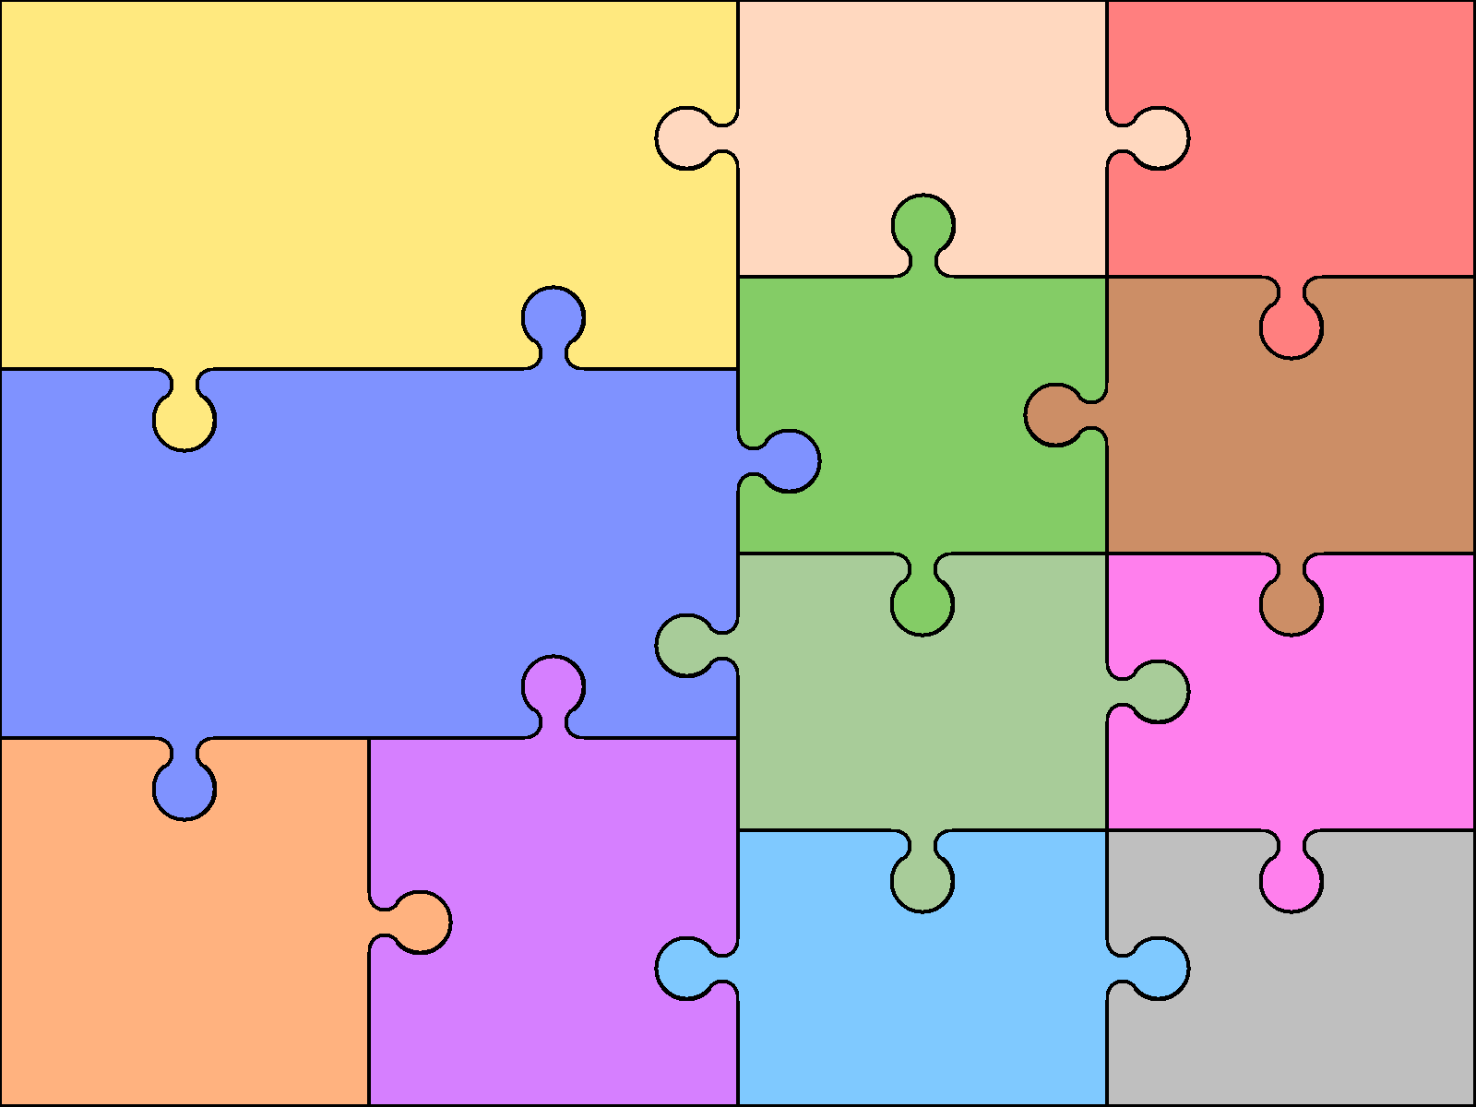
Art
- Painting and mixed media: colour splash
We will explore colour mixing using the primary and secondary colours
DT
- Mechanisms: wheels and axels
We will explore how wheels move, fixing wheels, designing and making our own wacky cars!

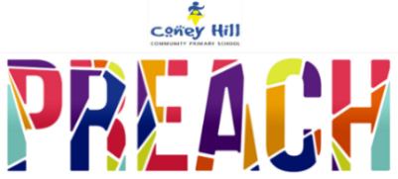  Year One Autumn Term  Theme: Toy box  Our theme this term is all about toys, sharing our favourite toys today and reading some excellent books featuring toy characters. We will be learning about toys in the past and how they have changed over time, comparing old toys to the toys we have today. We will think about what toys our parents and grandparents played with and develop our understanding of chronology. After half term, we will begin exploring our local area and the features within it, including how our school site has changed over time. |  | PE  - Fundamentals  - Yoga  - Gymnastics  - Ball Skills | Maths  - Number and place value up to 20  - Properties of 2D shapes  - Addition and subtraction  - Number and place value up to 100  - Addition and subtraction facts of 7 – 11  - Properties of 3D shapes
History  - To label timelines with pictures, words or phrases.  - To tell others about changes that have happened in my own life since I was born.  - To begin to understand how people find out about the past.  - To ask simple questions about the past.  - To tell others about the similarities and differences of the past to present day.  - To begin to identify significant people in a period of history studied, and begin to explain why they were important.  - Can I create a timeline of my chronology?  - How long have toys existed and what were they made of?  - What happened before my grandparents were born?  - What was life like when my grandparents were little?  - How has technology changed over the last century? |  |  | Writing  We will be writing…  - A traditional story (The Three Little Pigs)  - Letters (real and fictional)  - A character description  - An acrostic poem  - A recount  - Our own innovated stories
 |  | Phonics  - We are following the scheme ‘Unlocking Letters and Sounds’ to support your child’s phonics learning. We will recap Phase 4, focusing on blending consonant clusters.  - We will move on to learning phase 5 in the second part of the term.  Music  - Charanga units ‘Hey You!’, ‘Music in the way we walk’ and ‘Banana rap.’ We will explore rhythm, pitch and pulse, learning to sing songs and create our own music too! | Reading  - Guided reading sessions will take place daily, alongside phonics  - We will be focusing on using phonics to sound out and blend new vocabulary.  - To be able to answer retrieval questions using the question words: what, who, where, and when.  - We will be using our comprehension skills to influence our expression.  RE  - What does it mean to belong to a faith community?  - What do Christians believe God is like?  PSHCE (Jigsaw)  - Being me in my world  - Celebrating difference
Geography  - To use maps, atlases, globes and digital/computer mapping (Google Earth) to locate countries and cities.  - To use aerial images to recognise landmarks and basic physical features.  - To use a simple key to recognise physical and human features on a map  - To use simple fieldwork to observe, measure and record the human and physical features in the local area.  - Describe has the locality of school has changed over time. | Science  - Identify and name a variety of everyday materials.  - Distinguish between an object and the material from which it is made.  - Describe the simple properties of everyday materials.  - Compare and group a variety of materials on simple physical properties.  - To ask simple questions and gather and record observations.

